Image segmentation (a computer vision application)

1. Introduction
Image segmentation plays an important role in visualizing and understanding vision systems. Image segmentation involves subdivision of images into numerous segments or objects []. Segmentation is required in many applications [], such as calculation of tissue volumes and prediction of tumor boundary in medical image analysis, detecting the paths for cars and walking people and road signs in real-time in autonomous vehicles, analysis of satellite images to detect changes in environment such as change in the path of rivers, deforestation, urbanization, and augmented reality to name a few. Numerous image segmentation algorithms have been developed in literature, such as k-means clustering [], affinity-based segmentation [], transformers (Swin transformer, SegFormer) [], Convolutional Neural Networks (CNNs) such as U-Net [], Mask R-CNN [], DeepLab [] and HRNet [], and hybrid methods as Segment Anything Model (SAM) [] and 3D Gaussian Splatting []. However, for the past few years deep learning (DL) models like DeepLabv3 have shown an extraordinary performance in comparison to the other algorithms by achieving highest accuracy, which has resulted in a fundamental shift in the field of image segmentation. Figure 1 below shows the result of image segmentation of a deep learning model, DeepLabv3 [].
Image segmentation can be conceived as a pixel-wise classification problem, known as semantic segmentation or as a technique that differentiates individual objects called instance segmentation. In semantic segmentation every pixel is labelled to a specific category such as human, vehicles, buildings, or sky. Thus, semantic segmentation is a very hard task to perform as compared to traditional image classification that provides a single label of the image. Instance segmentation is the enhancement of semantic segmentation that not only classifies pixels but also identifies and separates every distinct object in an image e.g., differentiating every person or object in an image.
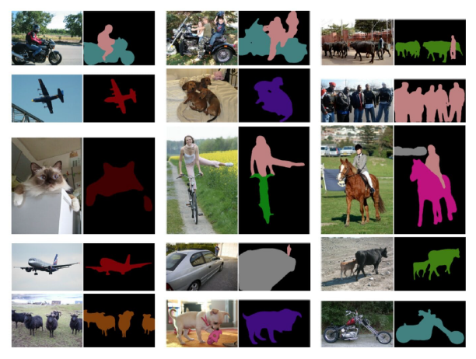
Figure 1 Segmentation results of DeepLabV3
2. Literature studies
This section offers a comprehensive review of different image segmentation methods rooted in deep learning. These segmentation methods are further categorized into distinct groups based primarily on their model architecture. There are many architectural components that are repeated in different segmentation methods, which show the use of common strategies to improve performance and accuracy.
One of the first deep learning methods for semantic image segmentation was proposed by Long et al. [] by developing a Fully Convolutional Network (FCN). As shown in figure 2 below, FCN considers only convolutional layers as contrary to traditional convolutional neural networks (CNNs) that rely on fully connected layers for classification, which allows FCN to work on images of varying sizes while generating segmentation maps of the same dimensions as of input image. The authors achieved this by modifying CNN architectures such as VGG16 and GoogLeNet by replacing their fully connected layers with fully convolutional layers. This transformation enabled the network to output dense spatial segmentation maps instead of conventional classification scores, making it highly effective for pixel-wise image segmentation tasks.
The model employs skip connections to enhance segmentation accuracy by merging information from both deep and shallow layers as shown in figure 3 below. The feature maps from the final layers are up sampled and combined with those from earlier layers. As a result, the model effectively integrates high-level semantic information from deeper, more abstract layers with fine-grained appearance details from the shallower layers. This fusion enables the production of precise and detailed segmentations. The authors tested the model on datasets such as PASCAL VOC, NYUDv2, and SIFT Flow, where it achieved state-of-the-art segmentation performance.
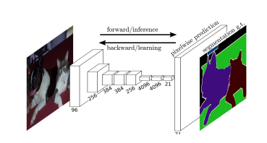
Figure 2 A fully FCN [13].
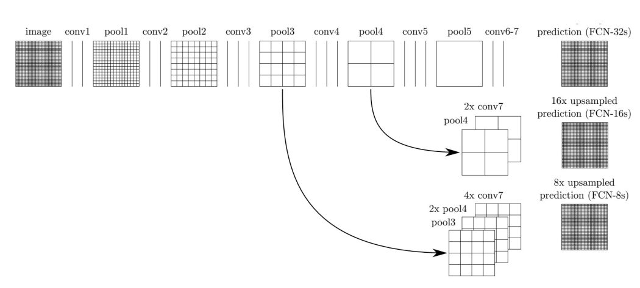
Figure 3 Skip Connections [ 13]
This research is a game-changer for image segmentation, showing that deep learning models can be trained from scratch to tackle semantic segmentation, no matter what the image size. The FCN model has won a lot of fans for how precise and dependable it is. That said, it’s not perfect. For one, it’s a bit sluggish for real-time use—like when you need instant results. It also struggles to pick up the bigger picture in an image efficiently and hits some roadblocks when it comes to 3D images. To get around these hiccups, researchers have rolled up their sleeves and come up with upgrades to speed it up, help it see the whole scene better, and make it flexible enough to handle trickier data.
Liu et al. [] introduced a model called ParseNet to improve upon FCNs by addressing their limitation in capturing global context information as shown in figure 4 below. Unlike traditional FCNs, which primarily focus on local features, ParseNet incorporates a global perspective by averaging the feature map of a given layer across the entire image. This results in a context vector that is normalized and expanded back to match the original feature map size. These adjusted feature maps are then combined to enhance segmentation accuracy. Essentially, ParseNet functions as an FCN but replaces standard convolutional layers with this context-aware module. FCNs, including ParseNet, have been widely used in various segmentation tasks such as brain tumor detection [], instance-aware semantic segmentation [], skin lesion identification [], and iris segmentation [].
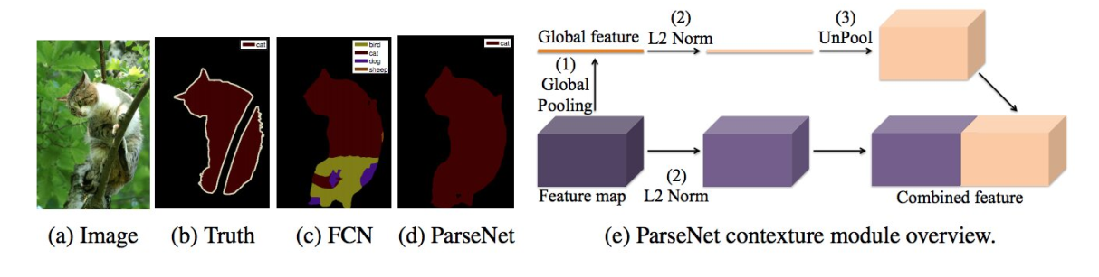
Figure 4 ParseNet provides smoother segmentation (d) than an FCN (c) [14].
FCNs perform very well, but they have cons as well, which can drastically bring down accuracy for correct segmentation. To overcome this weakness of FCN, there have been studies to incorporate algorithms, like probabilistic graphical models, including Conditional Random Fields (CRFs) and Markov Random Fields (MRFs), into their deep learning setups. For example, Chen et al. [] came up with a semantic segmentation method that teams up CNNs with fully connected CRFs. CNNs are good at spotting big-picture features, but when you get to their final layers, they’re not so great at pinpointing exact locations, which is a must for spot-on segmentation. It’s because CNNs are designed to ignore small shifts in an image, which can be used for classifying stuff but can leave object edges looking fuzzy. So, they paired CNN with a fully connected CRF, and the result sharpened up those boundaries as represented in figure 5 below. This approach seriously leveled up segmentation accuracy compared to what came before.
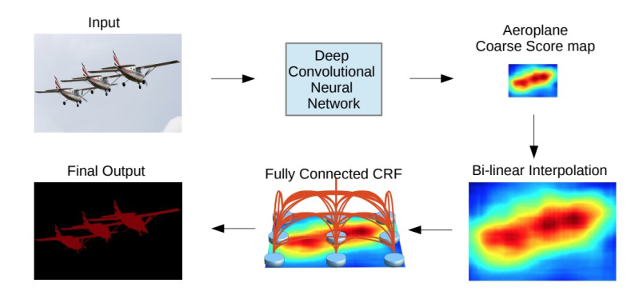
Figure 5 A CNN plus CRF model [19]
Schwing and Urtasun [] broke new ground in image segmentation by cleverly blending fully connected CRFs with CNNs. They figured out a way to train both parts together from start to finish, which seriously boosted segmentation accuracy. They put their method to the test on the PASCAL VOC 2012 dataset, and the results were amazing, which proved it could really work in the real world. Around the same time, Zheng et al. [] came up with their own take, mixing CNNs with CRFs too. Their work backed up the idea that adding context to the mix is key to getting sharper, more precise segmentations.
Another popular way to tackle image segmentation in deep learning is through the convolutional encoder-decoder setup. A lot of these models work by using an encoder to pull out key features from the image and a decoder to piece together the segmented version. You can split them into two main types: all-purpose models that handle segmentation jobs across different fields, and specialized ones fine-tuned for medical images, designed to meet the specific needs of healthcare.
Noh et al. [] introduced an early semantic segmentation model utilizing deconvolution (Figure 6), also known as transposed convolution. Their architecture comprises two main components: an encoder, which extracts features using convolutional layers from the VGG-16 network, and a deconvolutional decoder, which generates pixel-wise class probability maps. The decoder employs deconvolution and unpooling layers to identify class labels and predict segmentation masks. This approach demonstrated strong performance on the PASCAL VOC 2012 dataset, achieving the highest accuracy (72.5%) among models trained without external data at the time.
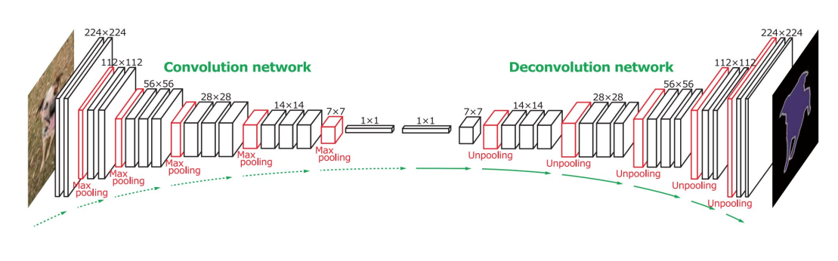
Figure 6 Deconvolutional semantic segmentation [22]
Building upon this idea, Badrinarayanan et al. [] developed SegNet, another convolutional encoder-decoder architecture for image segmentation. Like the deconvolution network, SegNet's core segmentation engine consists of an encoder derived from the 13 convolutional layers of the VGG-16 model and a corresponding decoder followed by a pixel-wise classification layer. The key innovation in SegNet lies in its decoder’s upsampling strategy. Instead of learning to upsample, SegNet uses max-pooling indices from the encoder’s pooling layers to perform non-linear upsampling, reducing computational complexity. The sparse upsampled feature maps are then convolved with trainable filters to generate dense segmentation maps. Compared to other architectures, SegNet is significantly more efficient, requiring fewer trainable parameters. Additionally, the authors proposed a Bayesian version of SegNet, which incorporates uncertainty estimation to enhance scene segmentation reliability [].
Another standout model in this group is the High-Resolution Network (HRNet) [], which has been making waves lately. Unlike older methods like DeConvNet, SegNet, U-Net, and V-Net that shrink images down and then try to rebuild them, HRNet keeps things sharp and detailed the whole way through. It does this by juggling multiple streams of convolutions at different resolutions all at once, letting them swap info as they go. Because it holds onto those fine details while blending in features from different scales, HRNet has become a go-to foundation for today’s semantic segmentation models. A bunch of newer tweaks build on it, adding things like self-attention tricks to make segmentation even better.
A lot of segmentation models were originally developed for medical and biomedical imaging, influenced by FCNs and encoder-decoder designs. U-Net [] and V-Net [] are two such models that started in medicine but ended up catching on in other areas too.
Ronneberger et al. [26] brought U-Net into the mix for tackling biological microscopy images. They wanted to make it work even with just a handful of labeled images, so they leaned hard into data augmentation tricks to stretch their dataset. U-Net’s setup has two main parts: a contracting path that grabs the big-picture context, and a matching expanding path that nails down the exact spots. The contracting side acts a bit like an FCN, using 3×3 convolutional layers to pull out key features while shrinking the image step by step. Then the expanding side flips things around with up-convolutions (sometimes called deconvolutions) to bring back the image size while trimming down the feature pile. To keep all the tiny details intact, they copy feature maps straight from the shrinking path over to the growing path at the right spots. At the end, a quick 1×1 convolution sorts each pixel into its class, giving out a spot-on segmentation map.
3. Explained methodologies
This section of the report will discuss some of the most used deep learning tools for computer vision, like CNNs, Recurrent Neural Networks (RNNs) [], Long Short-Term Memory (LSTM) [] networks, encoder-decoder models [23], and Generative Adversarial Networks (GANs) []. Recently, deep learning has been showing very promising results, and many new deep learning algorithms have been proposed like transformers, capsule networks, gated recurrent units (GRUs), and spatial transformer networks.
One big thing to think about with these models is how much labeled training data you’ve got. Starting from scratch for new projects or datasets sounds great, but it’s usually a tough haul because labeled data is hard to come by. That’s where transfer learning comes in handy. It’s all about taking a model trained on one job and tweaking it for something similar with a bit of new data. For example, a model built for sorting images on the massive ImageNet dataset can be reused for stuff like texture classification or spotting faces.
When it comes to image segmentation, a lot of researchers select pre-trained models from ImageNet to use as the encoder part of their setups. These models already know a ton about images, so segmentation networks can get the hang of things faster and with less labeled data. It’s a smart way to cut down on the grunt work of labeling while helping the model pick up solid image details for segmentation.
CNNs are one of the most widely used and successful architectures in deep learning, especially for computer vision applications. The concept of CNNs originated with Fukushima’s pioneering 'Neocognitron' research paper [], which was inspired by the hierarchical receptive field model of the human visual cortex, as proposed by Hubel and Wiesel. Subsequently, Waibel et al. [] advanced this by implementing CNNs with shared weights across temporal receptive fields, training them via backpropagation for phoneme recognition. LeCun et al. [] later refined the architecture, creating a CNN tailored for document recognition (shown in figure below), establishing a cornerstone for modern deep learning techniques in image analysis.
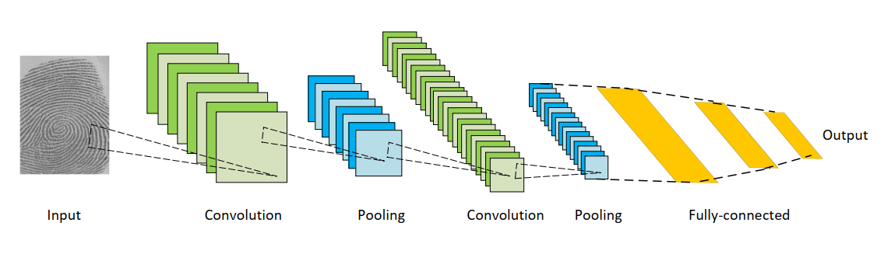
Figure 7 Architecture of CNNs [33]
There are three primary layers in the architecture of CNNs.
- Convolutional Layers – These apply filters (kernels) across input data to extract spatial features through convolution operations.
- Nonlinear Activation Layers – Functions like ReLU introduce non-linearity, allowing the network to capture complex patterns and relationships.
- Pooling Layers – These downsample feature maps by summarizing local regions with operations such as max pooling or average pooling, enhancing computational efficiency.
Units in these layers connect to localized receptive fields rather than all prior units. Stacking layers enables CNNs to build hierarchical features, progressing from edges to object representations. Weight sharing across receptive fields reduces trainable parameters compared to fully connected networks. Notable CNN architectures—AlexNet, VGGNet, ResNet, GoogLeNet, MobileNet, and DenseNet—have advanced network depth, efficiency, and feature extraction.
Recurrent Neural Networks (RNNs), in combination with Long Short-Term Memory networks (LSTMs), are deployed for handling data that comes in sequences, like speech, text, videos, or even stock prices over time. What makes them special is how they keep track of what’s come before. At each step, they take whatever new piece of info—let’s call it $X_{i}$—and mix it with a kind of memory, or hidden state, from the last step ($H_{i-1}$) as shown in figure below. This combination helps them churn out a result and update their memory for the next round.
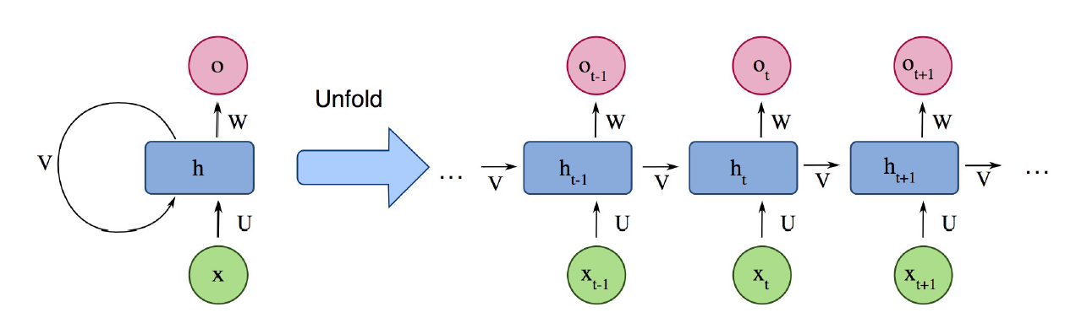
Figure 8 Architecture of RNN
The standard RNNs have some lacking: they’re not great at remembering things from way back. In real life, where context can stretch over long stretches, like following a conversation or a movie plot, this can trip them up. These problems are faced due to vanishing and exploding gradients, which mess with their ability to hold onto info over time. That’s where LSTMs comes in to save the day. Unlike regular RNNs, LSTMs come with a trio of gates (input, output, and forget), that act like traffic controllers for information. These gates work with a memory cell that can tuck away details and pull them back out when needed, even after a long stretch. That makes LSTMs a lot better at tackling jobs where distant connections matter.
4. Performance and results
Metrics for Segmentation Models
A robust segmentation model should be evaluated across multiple aspects, including accuracy, inference speed, and memory efficiency. While most research focuses on accuracy, factors such as computational cost and model complexity are also crucial, particularly for real-world applications such as autonomous driving and medical imaging. Below, we summarize some of the most widely used metrics for assessing segmentation performance.

Pixel Accuracy (PA)
Pixel accuracy represents the fraction of correctly classified pixels over the total number of pixels in an image. It is given by:
$$PA=\frac{\sum_{i=0}^{K}{p_{ii}}}{\sum_{i=0}^{K}{\sum_{j=0}^{K}{p_{ij}}}}$$

Where $p_{ii}$is the number of pixels correctly predicted for class $i$, $p_{ij}$is the number of pixels of class $i$ predicted as class $j$, and $K$ is the number of classes.
While simple, PA does not account for class imbalance and is often insufficient for evaluating complex segmentation tasks.

Mean Pixel Accuracy (MPA)
MPA is an extended version of PA that calculates accuracy for each class individually before computing the average
$$MPA=\frac{1}{K+1}\sum_{i=0}^{K}{\frac{p_{ii}}{\sum_{j=0}^{K}{p_{ij}}}}$$

This metric provides a more balanced evaluation across different object categories, especially for imbalanced datasets.

Intersection over Union (IoU) / Jaccard Index
The Intersection over Union (IoU), also known as the Jaccard Index, measures the overlap between predicted and ground-truth segmentations. It is defined as:
$$IoU(A,B)=\frac{\left|A∩B\right|}{\left|A∪B\right|}$$

Where $A$ is the predicted segmentation mask, and $B$ is the ground-truth segmentation mask.
$IoU$ is a widely adopted metric for semantic segmentation and is particularly useful
for evaluating object detection models.

Precision and Recall
Precision and recall are two essential metrics for evaluating segmentation performance. Precision measures how many of the predicted positive pixels are actually correct:
$$Precision=\frac{TP}{TP+FP}$$
Recall measures how many of the actual positive pixels were correctly predicted:
$$Recall=\frac{TP}{TP+FN}$$
Where TP (True Positives) are correctly predicted positive pixels, FP (False Positives) are incorrectly predicted positive pixels, and FN (False Negatives) are actual positive pixels missed by the model.

F1-Score
The F1-score is the harmonic mean of precision and recall, balancing the trade-off between both:
$$F1=\frac{2 ×Precision ×Recall }{Precision+ Recall}$$

This metric is particularly useful for imbalanced datasets, where precision and recall may differ significantly.

Dice Coefficient
The Dice Coefficient, commonly used in medical imaging, is a specialized form of the F1-score. It measures the similarity between the predicted and actual segmentation masks:
$$IoU(A,B)=\frac{2\left|A∩B\right|}{\left|A\left|+\right|B\right|}$$

Alternatively, when dealing with Boolean data such as binary segmentation maps, the Dice coefficient can be expressed as:
$$Dice=\frac{2TP}{2TP+FP+FN}$$

Since the Dice Coefficient and F1-score are mathematically equivalent, they are often used interchangeably in segmentation tasks.

Each of these metrics provides valuable insights into different aspects of model performance, ensuring a comprehensive evaluation of segmentation approaches. Properly considering these metrics allows researchers to compare and improve segmentation models more effectively.
Now, we’re diving into how different segmentation algorithms compare against each other using some popular benchmark datasets. Most models show their results based on these standard tests with common metrics, but a few skip that step, which makes it tricky to prepare a complete comparison analysis. Plus, only a handful of studies bother to share the detailed methodology to verify them on the local setup. This is very important, especially for real-world uses like drones, self-driving cars, or robots. These gadgets often run on very small devices with not much power or space to spare, so coming up with segmentation models that are quick and don’t require too many resources is a big deal.
The tables below show how different deep learning segmentation models have been doing on some well-known benchmark datasets. Table 1 starts with the PASCAL VOC test set, showing how much better these models have gotten since FCN came onto the scene. Table 2 moves to the Cityscapes test dataset, where newer models have shown improvement by about 23% compared to that original FCN. Then, Table 3 dives into the MS COCO Stuff test set, which is trickier than PASCAL VOC and Cityscapes, the best score is around 40% for mean Intersection over Union (mIoU). Finally, Table 4 with the ADE20k validation set, another tough nut to crack that’s even more complex than the others, proving just how solid today’s segmentation tricks have become.
Model | Backbone | Key Feature | mIoU(%)
FCN | VGG-16 | First DL-based segmentation model | 62.2
CRF-RNN | - | Conditional Random Fields (CRF) | 74.7
DeepLab-CRF | ResNet-101 | CRF for boundary refinement | 79.7
PSPNet | ResNet-101 | Pyramid Pooling Module | 85.4
DeepLabV3 | ResNet-101 | Atrous Spatial Pyramid Pooling (ASPP) | 85.7
EncNet | ResNet-101 | Context Encoding Module | 85.9
DFN | ResNet-101 | Two-stream fusion | 86.2
APC-Net | ResNet-101 | Adaptive Pyramid Context | 87.1
EMANet | ResNet-101 | Expectation-Maximization Attention | 87.7
DeepLabV3+ | Xception-71 | Improved ASPP + Encoder-Decoder | 89.0
EfficientNet+NAS-FPN | - | Neural Architecture Search (NAS) with FPN | 90.5
Table 1 Segmentation model accuracies on the PASCAL VOC test set.
Model | Backbone | Key Feature | mIoU(%)
FCN-8s | - | First CNN-based segmentation model | 65.3
Dilation10 | - | Dilated convolutions for larger receptive fields | 67.1
DeepLabV2 | ResNet-101 | Atrous convolutions | 70.4
RefineNet | ResNet-101 | Multi-path refinement | 73.6
GCN | ResNet-101 | Graph-based segmentation | 76.9
DUC-HDC | ResNet-101 | Dense upsampling | 77.6
PSPNet | ResNet-101 | Pyramid spatial pooling | 85.4
DFN | ResNet-101 | Dual branch refinement | 79.3
DenseASPP | DenseNet-161 | Dense atrous convolutions | 80.6
SPGNet | 2×ResNet-50 | Spatial pyramid grouping | 81.1
DeepLabV3 | ResNet-101 | Improved ASPP | 81.3
Table 2 Segmentation model accuracies on the Cityescapes dataset.
Model | Backbone | Key Feature | mIoU(%)
RefineNet | ResNet-101 | Feature refinement | 33.6
CCN | Ladder DenseNet-101 | Context capture with dense connections | 35.7
DANet | ResNet-50 | Dual attention mechanism | 37.9
DSSPN | ResNet-101 | Dense semantic propagation | 37.3
EMA-Net | ResNet-50 | Expectation-maximization attention | 37.5
SGR | ResNet-101 | Structured graph reasoning | 39.1
OCR | ResNet-101 | Object-context representation | 39.5
DANet | ResNet-101 | Dual self-attention | 39.7
EMA-Net | ResNet-50 | Expectation-maximization attention | 39.9
AC-Net | ResNet-101 | Adaptive context learning | 40.1
OCR | HRNetV2-W48 | High-resolution segmentation | 40.5
Table 3 Segmentation model accuracies on the MS COCO stuff dataset.
The tables above show that over the last five or six years, deep learning segmentation models have really improved their performance, boosting their mIoU scores by 25% to 42% across different datasets. A lot of studies use non-standard datasets, hand-pick parts of test sets, or skimp on explaining how they set things up, which makes it difficult to use their results in comparison analysis. Plus, lots of papers keep their code under wraps, which makes it tough to double-check their work. On the bright side, things are starting to shift. More research groups are jumping on board with standard benchmarks, sharing their datasets, and putting their code out into the open. It’s paving the way for better teamwork and trust in this whole segmentation field.
5. Challenges in Image Segmentation
Image segmentation is a very challenging task asit’s got some real hurdles tied to unbalanced data, and technological limits. These hurdles must be overcome to building sharper segmentation models.
Data Diversity and Quality
One big challenge is how messy and varied datasets can be. A lot of the ones available don’t cover different attributes like different lighting, people, or object looks, so the models end up lopsided and stumble when they see something new. For example, in the case of medical imaging, a model trained on one type of scan might totally flop on another machine or setup.
Then there’s the labeling problem. Segmentation needs every pixel tagged just right, and that’s very costly and slow. In places like medicine, you need experts to do it, which makes it even tougher to get enough good data.
Variability in Disease Characteristics
In medical stuff, diseases don’t follow a certain rules. Bladder tumors, for example, can show up in all sorts of sizes, shapes, and stages. Same goes for lung issues like pneumonia or COVID-19, where fuzziness or swelling mess with how clear the scans look, throwing segmentation for a loop.
Future Research Directions
Even with all the leaps forward, there’s promise on the horizon to tackle these challenges and make segmentation models shine brighter.
Self-Supervised and Few-Shot Learning
One path to follow is self-supervised learning, letting models figure things out from unlabeled data by spotting patterns on their own. It’s a game-changer for cutting down on the need for heaps of tagged pics and helps models roll with the punches across different fields. Then there’s few-shot learning, where models get smart with just a handful of examples. Super handy in medicine, where labeled data is like gold dust, pricey and rare.
Hybrid Models Mixing Old-School and New
The mash-up models like edge detection or graph methods with deep learning can borrow the best from both worlds, boosting accuracy without bogging down the system.
Transformer-Based Architectures for Image Segmentation
Transformers, are showing very promising results in the field of image segmentation. Vision Transformers (ViTs) can connect the dots across a whole picture, not just nearby bits, which is good for tricky scenes with lots of stuff going on.
Real-Time and Lightweight Models for Gadgets
For things like self-driving cars, drones, or portable medical gear, segmentation’s should be fast and lean. Future work’s all about tweaking these models to zip along in real time without compromising on quality.
Generalization Across Modalities and Domains
Models often trip over themselves when jumping between stuff like MRI, CT, or ultrasound scans. Research in the future should dig into ways to help them adapt between different domains.
6. Conclusion
Image segmentation has come a long way, but it’s still finding difficulty to deal with spotty data, wild disease differences, and tech demands. The way to move forward is to use self-supervised algorithms, hybrid architectures, transformers, and ones that can hop between fields. Overcoming these challenges will make segmentation sharper, faster, and ready for all sorts of real-life jobs.

References

[] R. Szeliski, Computer vision: algorithms and applications. Springer Science & Business Media, 2010.
[] D. Forsyth and J. Ponce, Computer vision: a modern approach. Prentice Hall Professional Technical Reference, 2002.
[] N. Dhanachandra, K. Manglem, and Y. J. Chanu, “Image segmentation using k-means clustering algorithm and subtractive clustering algorithm,” Procedia Computer Science, vol. 54, pp. 764–771, 2015.
[] Laradji, I.H., Saleh, A., Rodriguez, P., Nowrouzezahrai, D., Azghadi, M.R. and Vazquez, D. Weakly supervised underwater fish segmentation using affinity LCFCN. Scientific reports, 11(1), p.17379, 2021.
[] Fu, L., Chen, Y., Ji, W. and Yang, F. SSTrans-Net: smart Swin Transformer Network for medical image segmentation. Biomedical Signal Processing and Control, 91, p.106071, 2024.
[] Azad, R., Aghdam, E.K., Rauland, A., Jia, Y., Avval, A.H., Bozorgpour, A., Karimijafarbigloo, S., Cohen, J.P., Adeli, E. and Merhof, D., 2024. Medical image segmentation review: The success of u-net. IEEE Transactions on Pattern Analysis and Machine Intelligence.
[] Xu, Y., Li, D., Xie, Q., Wu, Q. and Wang, J., 2021. Automatic defect detection and segmentation of tunnel surface using modified Mask R-CNN. Measurement, 178, p.109316.
[] Wang, J. and Liu, X., 2021. Medical image recognition and segmentation of pathological slices of gastric cancer based on Deeplab v3+ neural network. Computer methods and programs in biomedicine, 207, p.106210.
[] Seong, S. and Choi, J., 2021. Semantic segmentation of urban buildings using a high-resolution network (HRNet) with channel and spatial attention gates. Remote Sensing, 13(16), p.3087.
[] Wu, J., Ji, W., Liu, Y., Fu, H., Xu, M., Xu, Y. and Jin, Y., 2023. Medical sam adapter: Adapting segment anything model for medical image segmentation. arXiv preprint arXiv:2304.12620.
[] Yu, Z., Chen, A., Huang, B., Sattler, T. and Geiger, A., 2024. Mip-splatting: Alias-free 3d gaussian splatting. In Proceedings of the IEEE/CVF conference on computer vision and pattern recognition (pp. 19447-19456).
[] L.-C. Chen, G. Papandreou, F. Schroff, and H. Adam, “Rethinking atrous convolution for semantic image segmentation,” arXiv preprint arXiv:1706.05587, 2017.
[] J. Long, E. Shelhamer, and T. Darrell, “Fully convolutional networks for semantic segmentation,” in Proceedings of the IEEE conference on computer vision and pattern recognition, 2015, pp. 3431– 3440.
[] W. Liu, A. Rabinovich, and A. C. Berg, “Parsenet: Looking wider to see better,” arXiv preprint arXiv:1506.04579, 2015.
[] G. Wang, W. Li, S. Ourselin, and T. Vercauteren, “Automatic brain tumor segmentation using cascaded anisotropic convolutional neural networks,” in International MICCAI Brainlesion Workshop. Springer, 2017, pp. 178–190.
[] Y. Li, H. Qi, J. Dai, X. Ji, and Y. Wei, “Fully convolutional instanceaware semantic segmentation,” in Proceedings of the IEEE Conference on Computer Vision and Pattern Recognition, 2017, pp. 2359–2367.
[] Y. Yuan, M. Chao, and Y.-C. Lo, “Automatic skin lesion segmentation using deep fully convolutional networks with jaccard distance,” IEEE transactions on medical imaging, vol. 36, no. 9, pp. 1876–1886, 2017.
[] N. Liu, H. Li, M. Zhang, J. Liu, Z. Sun, and T. Tan, “Accurate iris segmentation in non-cooperative environments using fully convolutional networks,” in 2016 International Conference on Biometrics (ICB). IEEE, 2016, pp. 1–8.
[] L.-C. Chen, G. Papandreou, I. Kokkinos, K. Murphy, and A. L. Yuille, “Semantic image segmentation with deep convolutional nets and fully connected crfs,” arXiv preprint arXiv:1412.7062, 2014.
[] A. G. Schwing and R. Urtasun, “Fully connected deep structured networks,” arXiv preprint arXiv:1503.02351, 2015.
[] S. Zheng, S. Jayasumana, B. Romera-Paredes, V. Vineet, Z. Su, D. Du, C. Huang, and P. H. Torr, “Conditional random fields as recurrent neural networks,” in Proceedings of the IEEE international conference on computer vision, 2015, pp. 1529–1537.
[] H. Noh, S. Hong, and B. Han, “Learning deconvolution network for semantic segmentation,” in Proceedings of the IEEE international conference on computer vision, 2015, pp. 1520–1528.
[] V. Badrinarayanan, A. Kendall, and R. Cipolla, “Segnet: A deep convolutional encoder-decoder architecture for image segmentation,” IEEE transactions on pattern analysis and machine intelligence, vol. 39, no. 12, pp. 2481–2495, 2017.
[] A. Kendall, V. Badrinarayanan, and R. Cipolla, “Bayesian segnet: Model uncertainty in deep convolutional encoder-decoder architectures for scene understanding,” arXiv preprint arXiv:1511.02680, 2015.
[] Y. Yuan, X. Chen, and J. Wang, “Object-contextual representations for semantic segmentation,” arXiv preprint arXiv:1909.11065, 2019.
[] O. Ronneberger, P. Fischer, and T. Brox, “U-net: Convolutional networks for biomedical image segmentation,” in International Conference on Medical image computing and computer-assisted intervention. Springer, 2015, pp. 234–241.
[] F. Milletari, N. Navab, and S.-A. Ahmadi, “V-net: Fully convolutional neural networks for volumetric medical image segmentation,” in 2016 Fourth International Conference on 3D Vision (3DV). IEEE, 2016, pp. 565–571.
[] D. E. Rumelhart, G. E. Hinton, R. J. Williams et al., “Learning representations by back-propagating errors,” Cognitive modeling, vol. 5, no. 3, p. 1, 1988.
[] S. Hochreiter and J. Schmidhuber, “Long short-term memory,” Neural computation, vol. 9, no. 8, pp. 1735–1780, 1997.
[] I. Goodfellow, J. Pouget-Abadie, M. Mirza, B. Xu, D. Warde-Farley, S. Ozair, A. Courville, and Y. Bengio, “Generative adversarial nets,” in Advances in neural information processing systems, 2014, pp. 2672–2680.
[] K. Fukushima, “Neocognitron: A self-organizing neural network model for a mechanism of pattern recognition unaffected by shift in position,” Biological cybernetics, vol. 36, no. 4, pp. 193–202, 1980.
[] A. Waibel, T. Hanazawa, G. Hinton, K. Shikano, and K. J. Lang, “Phoneme recognition using time-delay neural networks,” IEEE transactions on acoustics, speech, and signal processing, vol. 37, no. 3, pp. 328–339, 1989.
[] Y. LeCun, L. Bottou, Y. Bengio, P. Haffner et al., “Gradient-based learning applied to document recognition,” Proceedings of the IEEE, vol. 86, no. 11, pp. 2278–2324, 1998.

